**Experiment 5**

**Aim** – Installing and running Haskell Compiler

Steps for Installing Haskell

Step 1 : Goto https://www.haskell.org/ghcup/

Step 2 : Goto download

Step 3 : Show Windows Packages

Step 4 : Copy - Set-ExecutionPolicy Bypass -Scope Process -Force;[System.Net.ServicePointManager]::SecurityProtocol = [System.Net.ServicePointManager]::SecurityProtocol -bor 3072; try { Invoke-Command -ScriptBlock ([ScriptBlock]::Create((Invoke-WebRequest https://www.haskell.org/ghcup/sh/bootstrap-haskell.ps1 -UseBasicParsing))) -ArgumentList $true } catch { Write-Error $_ }

Step 5 : Open windows powershell in admin mode

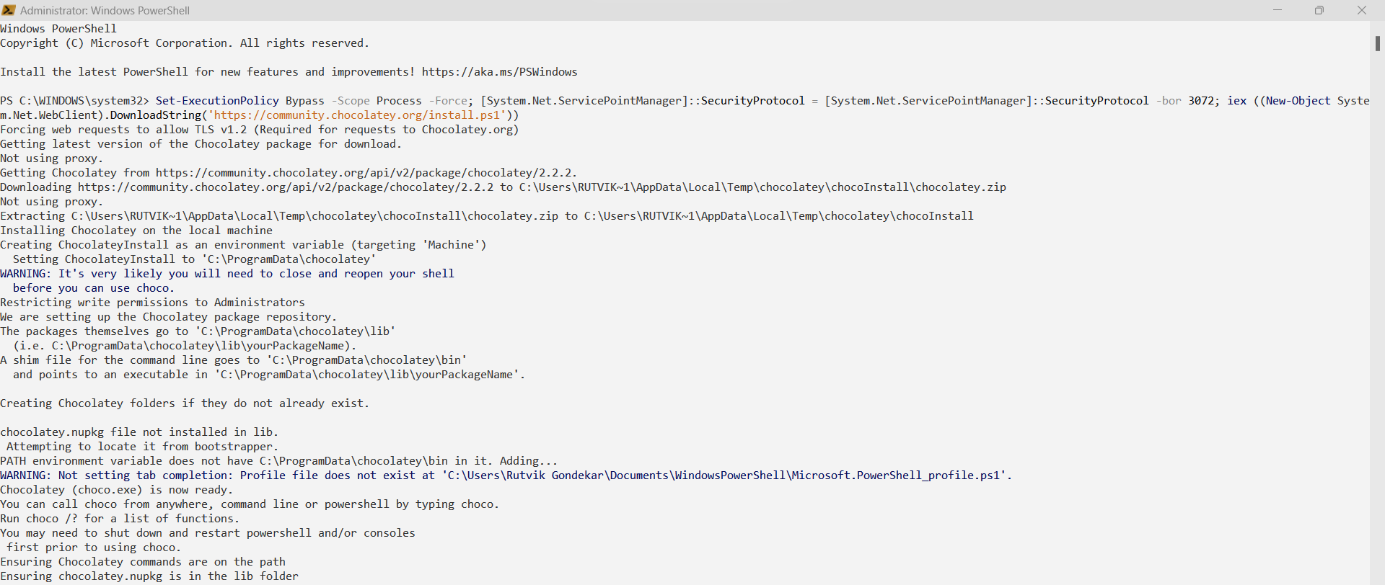Step 6 : Paste above path and hit Enter

Step 7: After chocolatey is installed, use command *choco --version* in command prompt to verify installation

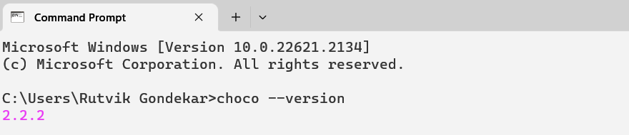

Step 8: Now run the command *choco install ghc* in command prompt/powershell running as administrator

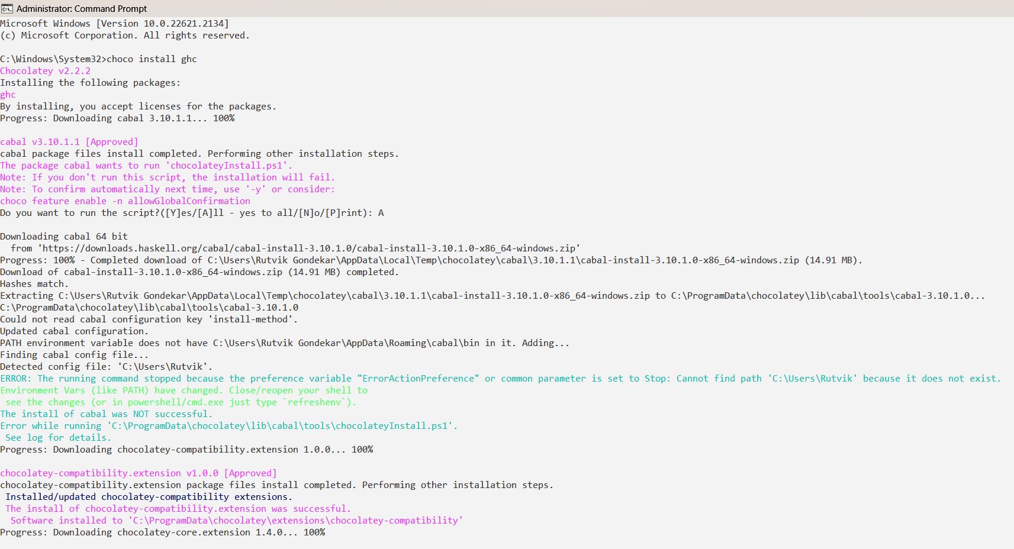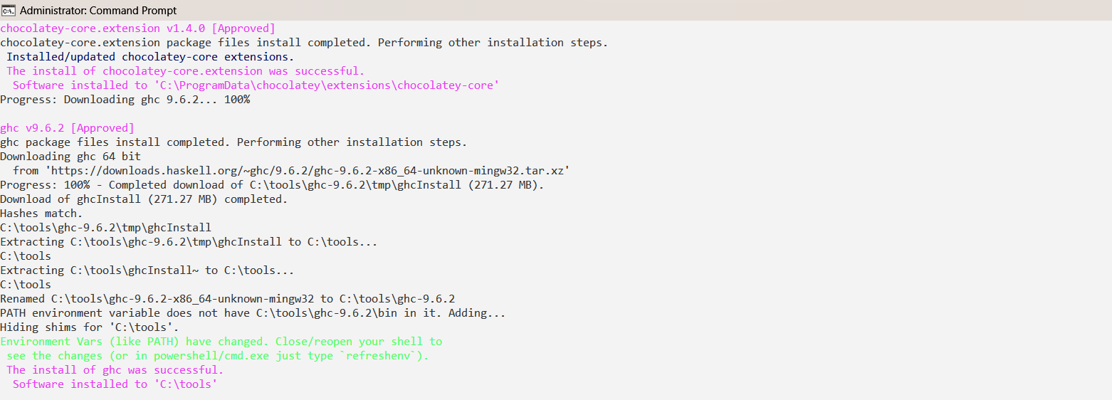

Step 9: To verify ghc installation type the command *ghc --version* in command prompt

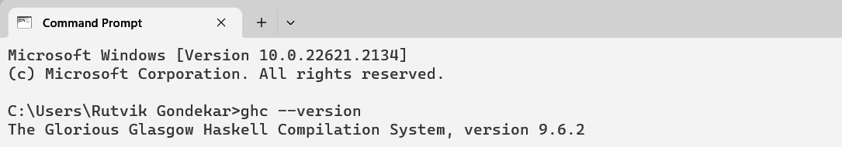

Thus the Installation is completed

To test it lets execute and example program

To execute a program using Haskell

Do the following steps

Step 1: Write the following program and save it with ‘.hs’ extension

main :: IO ()

main = do

putStrLn "Enter the first number: "

input1 <- getLine

putStrLn "Enter the second number: "

input2 <- getLine

let a = read input1 :: Int

b = read input2 :: Int

putStrLn "The addition of two numbers is: "

print(a+b)

Step 2: Open the command prompt and change directory to where the file is stored

Step 3: Type command *ghci*  to start the ghc interpretor

Step 4: Use the command *:load <filename.hs>*  to load the file in ghc

Step 5: Use the command *:main*  to run the main function

Step 6: After the completion of execution of program use command *:quit*  to exit ghci

